Tyler Citrin

CSCI-343 Midterm Review

**I. Iterators**

Implement an iterator over a custom linkedlist class you made that **skips every other element**.

public Iterator<T> iterator() {

return new Iterator<T>() {

Node<T> currNode = head;

Node<T> previous = null;

public boolean hasNext() {

}

public T next() {

}

};

}

**Why do we use iterators?**

**II. Doubly Linked List** *(represented just by the root node here)*

**2.1 Draw a simple representation of a doubly linked list.**

**2.2 Now write code to determine if that linked list is circular**

public boolean isCircular(Node<T> list) {

}

**2.4** **Draw a simple representation of a doubly linked list, then the result of deleting the tail**

**2.5 Write code to delete tail of doubly linked list and then realigns it accordingly, then return the head**

public Node<T> deleteTail(Node<T> list) {

}

III. **Arrays**

3.1 Matrices: write a function that transposes a matrix in place, in the shortest time possible, then circle the numbers below that are checked.

[{1, 2, 3, 4},

{5, 6, 7, 8},

{9, 10, 11, 12},

{13, 14, 15, 16}]

3.2 Merge-sort is an algorithm that recursively halves, sorts, and merges an array.

For example, with an array [3, 1, 4, 2], the first split would yield [3, 1], [4, 2], and subsequently

[3], [1], [4], [2]. The next step would be to put it put it back together in sorted order.

[3, 1, 4, 2]

[3, 1] [4, 2]

[3] [1] [4] [2]

Draw the full recursive tree (this means it has a root at the top and bottom) of [38, 27, 43, 3, 60, 10].

**3.2 using your intuition, with the number of comparisons made, what do you anticipate the run time (big-o complexity) of this algorithm to be and why? (hint: what happens to n every time?)**

**IV. Heaps**

**4.1 Draw a simple heap of size 8 nodes**

**4.2 Draw an INVALID heap of size 8 nodes, breaking the left-fill-first rules**

**4.3 Given an array that is supposed to represent a heap, write a function to determine whether or not it maintains the heap ordering property**

**V. Binary Trees**

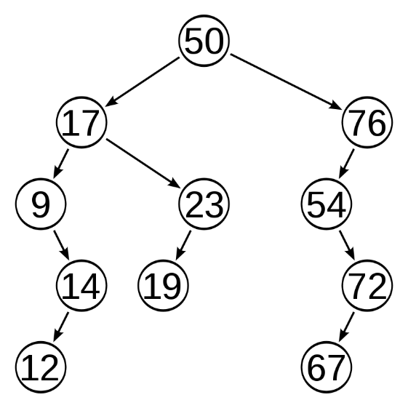**5.1 Fill in the following properties below of the binary tree**

**Height =**

**Levels =**

**Size** *(Total Number of nodes***) =**

**Diameter** *(longest distance between nodes)* **=**

**Width** *(longest distance between nodes on same level including null nodes)* **=**

**5.2 Given a simple binary tree, draw the mirror reflection of it. (hint: draw one and then the transformation of it)**

**5.3** **Write a recursive function to accomplish the above.**

**BIG O Calculations**

What is the runtime of binary search?

What is the runtime of heapsort?